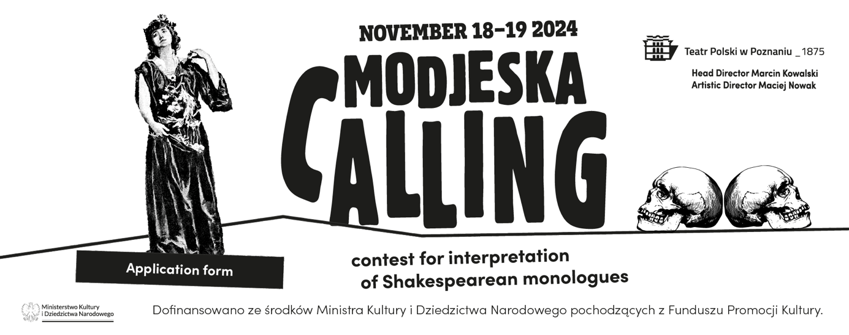
Please fill in the form electronically and send it as a PDF file to the address: modjeska@teatr-polski.pl
1. Full name:
……………………………………………
2. Email address:
……………………………………………
3. Phone number:
……………………………………………
4. Date of birth:
……………………………………………
5. Education (university name, field of study, start and end date):
……………………………………………
6. Professional experience (acting roles, please list up to 10). For non-students/graduates of acting fields from theatre schools, at least 5 performed roles within a minimum of 5 years must be listed to qualify for the competition:
………………………………………………
(date, role, title of the play, location)
7. Bibliographic reference of the selected monologue (title of the play, name of the character, translator's name, year of publication, page range). Applications that do not include this information will not be considered:
………………………………………………

8.The text of the selected monologue. (If the monologue is performed in a language other than Polish, the English version of the monologue must also be attached). Maximum 3200 characters including spaces:
………………………………………………
ATTENTION! INCOMPLETE APPLICATIONS THAT DO NOT COMPLY WITH THE REGULATIONS OR ARE SENT IN INCORRECT FORMATS WILL NOT BE CONSIDERED.

Information on the processing of personal data
Due to Regulation (EU) 2016/679 of the European Parliament and of the Council of 27 April 2016 on the protection of natural persons with regard to the processing of personal data and on the free movement of such data, and repealing Directive 95/46/EC (General Data Protection Regulation), hereinafter referred to as "GDPR", we hereby inform you:The controller of your personal data is the Polish Theatre with its registered office in Poznań, ul. 27 Grudnia 8/10, 61-737 Poznań, registered in the Register of Cultural Institutions maintained by the Department of Culture of the Poznań City Hall under number RIK-XI, NIP: 7781003125. For all matters related to the protection and processing of personal data, and the exercise of your rights, please contact the Data Protection Officer appointed by the Administrator via email at rodo@teatr-polski.pl or in writing at the Administrator's address.
Your personal data will be processed for the purpose of conducting and implementing the competition for actresses and actors for the interpretation of Helena Modrzejewska's monologues – Modjeska Calling – including the publication of information about the results of the competition and the winners. The basis for the processing of your personal data will be your consent, pursuant to Article 6(1)(a) of the GDPR. Additionally, the data of the winners will be processed for the purpose of concluding a contract, based on Article 6(1)(b) of the GDPR, and for the fulfillment of legal obligations incumbent on the Administrator (e.g., accounting, tax obligations) pursuant to Article 6(1)(c) of the GDPR.
Your data will be processed by authorized employees and associates of the administrator. The recipients of the personal data will be entities providing services to the administrator, particularly IT service providers and hosting services. The appointed jury will also be a recipient of the data. Your data will not be transferred to third countries (outside the European Union or European Economic Area).
Your personal data will be processed and stored for the period necessary to achieve the purpose for which they were collected, and in justified cases, in accordance with the archiving periods specified by the relevant laws or the Act of July 14, 1983, on the national archival resource and archives, including the Regulation of the Prime Minister of January 18, 2011, on the office instructions, uniform material lists, and instructions on the organization and scope of the activities of company archives.
You have the following rights:
- The right to access your personal data
- The right to rectify, delete, or restrict the processing of your data
- The right to data portability
You also have the right to lodge a complaint with the supervisory authority, i.e., the President of the Personal Data Protection Office, if you believe that the processing of your data violates data protection regulations.
For data processed based on consent, you have the right to withdraw your consent at any time without affecting the legality of the processing carried out based on consent before its withdrawal. However, certain data that the Administrator is required to retain under the law will not be deleted. If you believe that the processing of your personal data violates the regulations, you have the right to lodge a complaint with the supervisory authority responsible for data protection, i.e., the President of the Personal Data Protection Office.
Providing your personal data is voluntary but necessary to participate in the competition. Failure to consent to the processing of personal data will result in the rejection of the competition application. Providing personal data by the winner is necessary to conclude a contract and award the prize. Failure to provide personal data will prevent the conclusion of the contract and the payment of the prize.
I consent to the processing of my personal data

……………………………………………………
(name and surname, date)

Link to Shakespeare monologues played by Helena Modrzejewska: https://teatr-polski.pl/wp-content/uploads/2021/03/Role-Heleny-Modrzejewskiej.pdf

